

Lab 07: CS 110

**Function Arguments/Parameters, Variable Scope,**

**Debugging Basics**

**Muhammad Mujtaba**

**CMD ID: 540040**

[mmujtaba.bese25seecs@seecs.edu.pk](mailto:mmujtaba.bese25seecs@seecs.edu.pk)

**Class:** BESE 16B

**Batch:** 2k25

# Task 1 [CLO 2]: Bank Loan Payment Calculator [Pass by Value + Default Parameters]

## CODE:

#include <iostream>

#include <cmath>

#include <string>

#include <iomanip>

#include <limits>

struct Range

{

float min;

float max;

// get min and max of data type

static Range getDefault()

{

return Range{std::numeric_limits<float>::min(), std::numeric_limits<float>::max()};

}

};

// FUNCTIONS PROTOTYPES

float monthly_payment(float loan_amount, float annual_interest_rate, int number_of_payments = 12);

// struct is used so user needs to either define both min and max or none at all; to reduce clutter

float input(const std::string &message, Range range = Range::getDefault());

// MAIN

int main()

{

float loan_amount = input("Loan Amount", {0.0f, 1000000.0f});

float annual_interest_rate = input("Annual Interest Rate", {0.0f, 100.0f});

float number_of_payments = input("Number Of Payments", {1.0f, 600.0f}); // up to 50 years

std::cout << std::fixed << std::setprecision(2);

std::cout << "Monthly Payment: "

<< monthly_payment(loan_amount, annual_interest_rate, number_of_payments)

<< '\n';

// test with default test cases

std::cout << "CASE 1: " << monthly_payment(100000, 12, 12) << '\n';

std::cout << "CASE 2: " << monthly_payment(500000, 10, 60) << '\n';

std::cout << "CASE 3: " << monthly_payment(100000, 12) << '\n';

std::cout << "CASE 4: " << monthly_payment(10000, 12) << '\n';

std::cin.ignore();

std::cin.get();

return 0;

}

// FUNCTIONS DECLERATIONS

float monthly_payment(float loan_amount, float annual_interest_rate, int number_of_payments)

{

// calculate monthly rate

const float monthly_rate = annual_interest_rate / (12 * 100);

// substituiting into formula

return (monthly_rate * loan_amount) / (1 - std::pow(1 + monthly_rate, -number_of_payments));

}

float input(const std::string &message, Range range)

{

float result = -1;

std::cout << message << ": ";

while (true)

{

std::cin >> result;

// stopping the program from going crazy when alphabet is entered

if (!std::cin.fail()) // if no error is detected in cin

{

if (result >= range.min && result <= range.max)

break;

std::cout << std::fixed << std::setprecision(2);

std::cout << "> Input a number between " << range.min << " and " << range.max << ": ";

std::cout.unsetf(std::ios::fixed); // revert std::fixed

continue;

}

// error in user input

std::cin.clear(); // clear error flag

std::cin.ignore(std::numeric_limits<std::streamsize>::max(), '\n'); // discard the input

// ^ says discard all input including newline character

std::cout << "> Please input a valid input: ";

}

return result;

}

## OUTPUT:

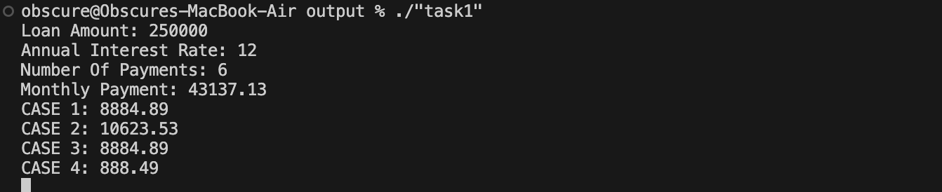

# Task 2 [CLO 2]: Celsius-Fahrenheit Converter [Pass by Reference]

## CODE:

#include <iostream>

#include <tuple>

enum class TempError

{

None = 0,

BelowAbsoluteZero = 1

};

TempError adjustTemp(double &temp, bool cToF);

int main()

{

std::tuple<double, bool> testcases[10] = {

{25.0, true}, // valid C

{-300.0, true}, // invalid C

{0.0, true}, // valid C

{100.0, true}, // valid C

{-500.0, false}, // invalid F

{32.0, false}, // valid F

{212.0, false}, // valid F

{-460.0, false}, // invalid F

{37.0, true}, // valid C

{-40.0, true} // same C and F

};

for (auto &[temp, isC] : testcases)

{

double tempBefore = temp;

TempError error = adjustTemp(temp, isC);

switch (error)

{

case TempError::None:

std::cout << tempBefore << (isC ? " C" : " F") << " = " << temp << (!isC ? " C" : " F") << "\n";

break;

case TempError::BelowAbsoluteZero:

std::cout << "ERROR: Invalid Tempurature (" << tempBefore << "" << (isC ? " C" : " F") << "): Tempurature is below Absolute Zero.\n";

break;

default:

std::cout << "ERROR: Unknown Error Occured\n";

break;

}

}

std::cin.ignore();

std::cin.get();

return 0;

}

TempError adjustTemp(double &temp, bool cToF)

{

TempError errorFlag = TempError::None;

if (cToF)

{

// check if temp is above -273.15 C

if (temp < -273.15)

{

errorFlag = TempError::BelowAbsoluteZero;

}

else

temp = (temp * 9 / 5) + 32;

}

else

{

// check if temp is above -459.67 F

if (temp < -459.67)

{

errorFlag = TempError::BelowAbsoluteZero;

}

else

temp = (temp - 32) * 5 / 9;

}

return errorFlag;

}

## OUTPUT:

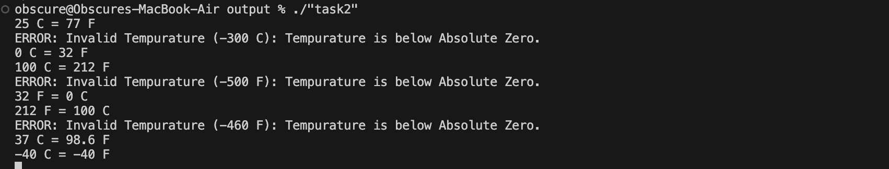

# Task 3 [CLO 1]: Inline Functions

## CODE:

#include <iostream>

#include <iomanip>

enum class GravitationalForceError

{

None = 0,

ZeroRadius = -1,

NegativeMass = -2,

};

inline double calculateForce(double first_mass, double second_mass, double radius, GravitationalForceError *error);

int main()

{

std::tuple<double, double, double> testcases[10] = {

{5.972e24, 7.348e22, 3.844e8}, // Earth and Moon

{1.989e30, 5.972e24, 1.496e11}, // Sun and Earth

{1.989e30, 7.348e22, 1.496e11 + 3.844e8}, // Sun and Moon

{5.972e24, 0.0, 3.844e8}, // Earth and zero mass

{-5.972e24, 7.348e22, 3.844e8}, // Negative mass > ERROR

{5.972e24, 7.348e22, 0.0}, // Zero radius > ERROR

{1.0e3, 1.0e3, 1.0}, // Small masses

{1.0e10, 1.0e10, 1.0e5}, // Large masses

{1.0, 1.0, 1.0}, // Unit masses

{2.0, 3.0, 4.0} // Random values

};

for (const auto &[first_mass, second_mass, radius] : testcases)

{

GravitationalForceError error = GravitationalForceError::None;

double result = calculateForce(first_mass, second_mass, radius, &error);

switch (error)

{

case GravitationalForceError::None:

std::cout << "Calculated Force: " << result << " N\n";

break;

case GravitationalForceError::ZeroRadius:

std::cout << "ERROR: Radius is zero.\n";

break;

case GravitationalForceError::NegativeMass:

std::cout << "ERROR: One of the masses of negative.\n";

break;

default:

std::cout << "ERROR: Unknown Error Occured\n";

break;

}

}

std::cin.ignore();

std::cin.get();

return 0;

}

inline double calculateForce(double first_mass, double second_mass, double radius, GravitationalForceError *error = nullptr)

{

if (first_mass < 0 || second_mass < 0)

{

*error = GravitationalForceError::NegativeMass;

return -1;

}

if (radius == 0)

{

*error = GravitationalForceError::ZeroRadius;

return -2;

}

constexpr double G_CONSTANT = 6.67430e-11;

return (G_CONSTANT * first_mass * second_mass) / (radius * radius);

}

## OUTPUT:

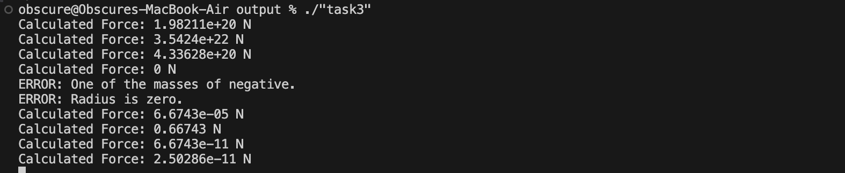

# Task 4 [CLO 1]: Understanding scope of variables and debugging

## CODE:

#include <iostream>

// Global variable for tax rate

double taxRate = 0.08; // 8% tax rate

double calculateFinalPrice(double price, int quantity)

{

double total; // FIX 1: initialize

double discount = 0.1;

total = price * quantity * (1 + taxRate) * (1 - discount); // FIX 2: use correct formula

// FIX 3: remove local `taxRate` variable

// FIX 4: Remove unneccessay scope

std::cout << "Debug: Tax rate used: " << taxRate << std::endl;

return total;

}

int main()

{

double price = 50.0;

int quantity = 2;

double expectedTotal = (price * quantity) * (1 + 0.08) * (1 - 0.1);

// Expected: 50 * 2 * 1.08 * 0.9 = 97.2

double result = calculateFinalPrice(price, quantity);

std::cout << "Total cost for " << quantity << " items at $" << price

<< ": $" << result << std::endl;

// Test with different values

price = 100.0;

quantity = 1;

expectedTotal = (price * quantity) * (1 + 0.08) * (1 - 0.1); // Expected: 100 * 1 * 1.08 * 0.9 = 97.2

result = calculateFinalPrice(price, quantity);

std::cout << "Total cost for " << quantity << " items at $" << price

<< ": $" << result << std::endl;

return 0;

}

## OUTPUT:

